**[](http://www.mdhadallas.org/)**

**Case Managers Roundtable 2019**

**What:** Network and learn with and from your fellow case managers. (Swords and armor optional.)

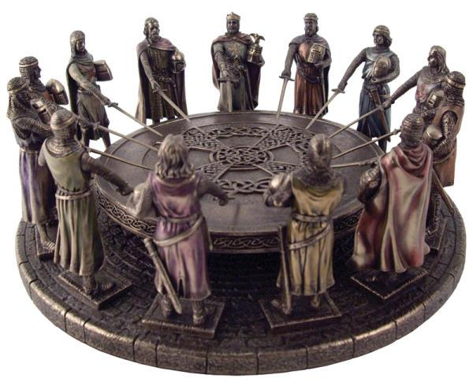

**When: Fourth Wednesday of the month, 12-1.30pm** (Nov.-Dec. combined)

*January 23*

*February 27*

*March 27*

*April 24*

*May 22*

*June 26*

*July 24*

*August 28*

*September 25*

*October 23*

*December 4*

**Where: United Way of Metropolitan Dallas**, 1800 N. Lamar St.,Dallas, Texas 75202. Coffee and water provided. Attendees may bring brown-bag lunches.