
CoC General Assembly 2019

What: Join us, as we work together to make homelessness, in Dallas and Collin Counties, rare, brief and nonrecurring. (Shields and spears optional.)

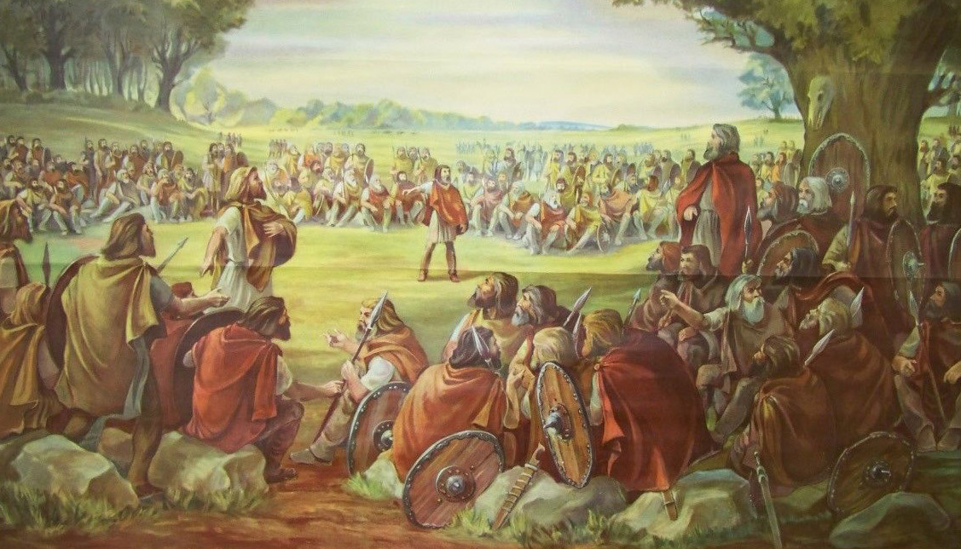

When: Fourth Tuesday of the month, 9-10.30am (Nov.-Dec. combined)

January 22
February 26
March 26
April 23
May 28
June 25
July 23
August 27
September 24
October 22
December 3

Where: United Way of Metropolitan Dallas, 1800 N. Lamar St., Dallas, Texas 75202. Coffee and water provided.

