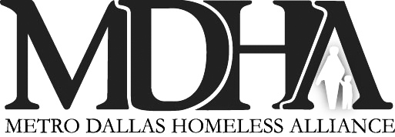

**FLEX-DFB**

**MDHA Furniture Flex Fund Request Form**

**Date: Client Name:** ___________________ **HMIS ID Number: ­­­­­­­­­**_______________________

**Requesting Agency Name:**

|  |  |  |
| --- | --- | --- |
| Twin or Full Bed (Matt/Box) ____ |  | Sofa Sleeper ____ |
| Queen Bed (Matt/Box) ____ |  | Upholstered Chair ____ |
| Crib (New) ____ |  | Side Chair (Living Room) ____ |
| Nightstand ____ |  | End Table ____ |
| Chest of Drawers ____ |  | Coffee Table ____ |
| Dresser ____ |  | Dining Table (2 Chairs) ____ |
| Loveseat ____ |  | Dining Table (4 Chairs) ____ |
| Sofa ____ |  | Side Chair (Dining) ____ |
| Bed Frame (New Twin/Full) ____ |  | Total Items ____ |
| **\*\*\*NOTE: Items are not guaranteed in stock.** | | |

**CASE MANAGER NOTES:**

***How does this request improve the client’s ability to achieve housing, employment or self-sufficiency?***

***Detail why there are no other resources or funds for the request?***

*By our signatures, we affirm that the client is in a CoC, Emergency Shelter, Street Outreach (or equivalent case management) program****.*** *The client has a completed HUD Assessment in the MDHA HMIS. We further affirm that the client and the agency have no other resources to pay for the needed items listed above.*

***PRINT CLEARLY***

**AGENCY INSTRUCTIONS:**

Submissions must be scanned to pdf and emailed to:  
Flex@MDHADallas.org

**Case Manager Signature: (X)**

**Case Manager Name:**

**Case Manager Email:**

**Case Manager Telephone:**

**Agency Supervisor/Program Manager Signature:**

**MDHA Approval: ____________________________________________**

OFFICE USE ONLY: 🞏CAS – Match 🞏 Veteran 🞏 Re-Entry