**Interim Coordinated Assessment System**

**System Guidance:**

1. Discontinue uploading documentation to IRIS as of 09/01/2019.
2. Gather all the neighbor’s documentation, i.e. documentation of homelessness, documentation of disability
3. As documentation of homelessness, disability, and critical documents are obtained they should be uploaded to BaseCamp, under your agency’s folder as a zip file. ***Please see below to upload as a zip file.*** 
   * + - In the subject line, type the client’s first initial and last name and the HMIS number (Please note: ***Do Not added any other Personal Identifying Information in the text box.)***
       - In the message, please indicate what is being uploaded (Ie. Homeless doc form, SSI awards letter, Texas Id) (Please note: ***Do Not added any other Personal Identifying Information in the text box.)***
       - Attach all documentation and post the message
4. Complete the VI-SPDAT in IRIS until September 23, 2019 and starting October 1, 2019 Complete the VI-SPDAT in Client Track
5. ***There will be a CAS Black out starting September 24, 2019 until October1, 2019***
6. Complete the online DOPS form at <https://hipaa.jotform.com/92404892042152>

Remember:

* You ***MUST*** indicate the family size
* You ***MUST*** indicate what assessment is being used (ie. VI-SPDAT or SPDAT)
* You ***MUST*** indicate the assessment score
* Please check ***yes or no*** to the listed disabilities.

1. MDHA will generate a weekly HPL every Friday.
2. Housing providers will approve or deny households within 7 days of referral by emailing Melanie Bostic at Melanie.Bostic@mdhadallas.org
3. Housing providers will update information in HMIS to reflect the updated housing status within 48 hours of the household’s move-in date.

Save as a Zip file:

1. Select all file by holding Ctrl and clicking all the files needed
2. Right click your mouse and click send to…..
3. Finally click Compressed (zipped) folder

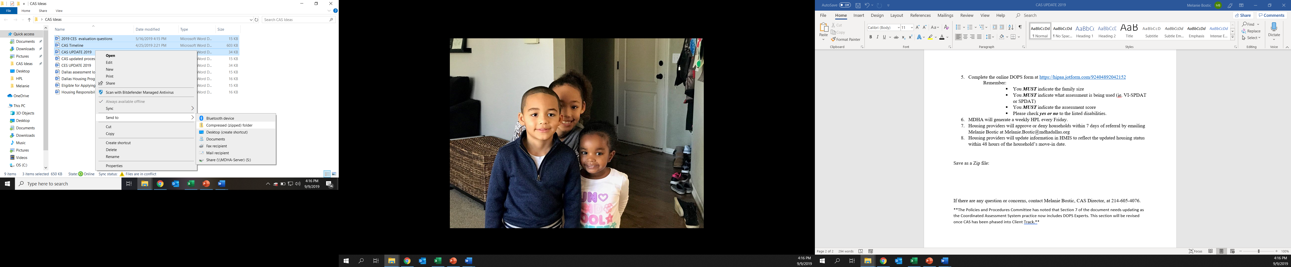

If there are any question or concerns, contact Melanie Bostic, CAS Director, at 214-605-4076.

**The Policies and Procedures Committee has noted that Section 7 of the document needs updating as the Coordinated Assessment System practice now includes DOPS Experts. This section will be revised once CAS has been phased into Client Track. **