**[](http://www.mdhadallas.org/)**

**CoC General Assembly 2020**

**What:** Join us, as we work together to make homelessness, in Dallas and Collin Counties, rare, brief and nonrecurring. (Shields and spears optional.)

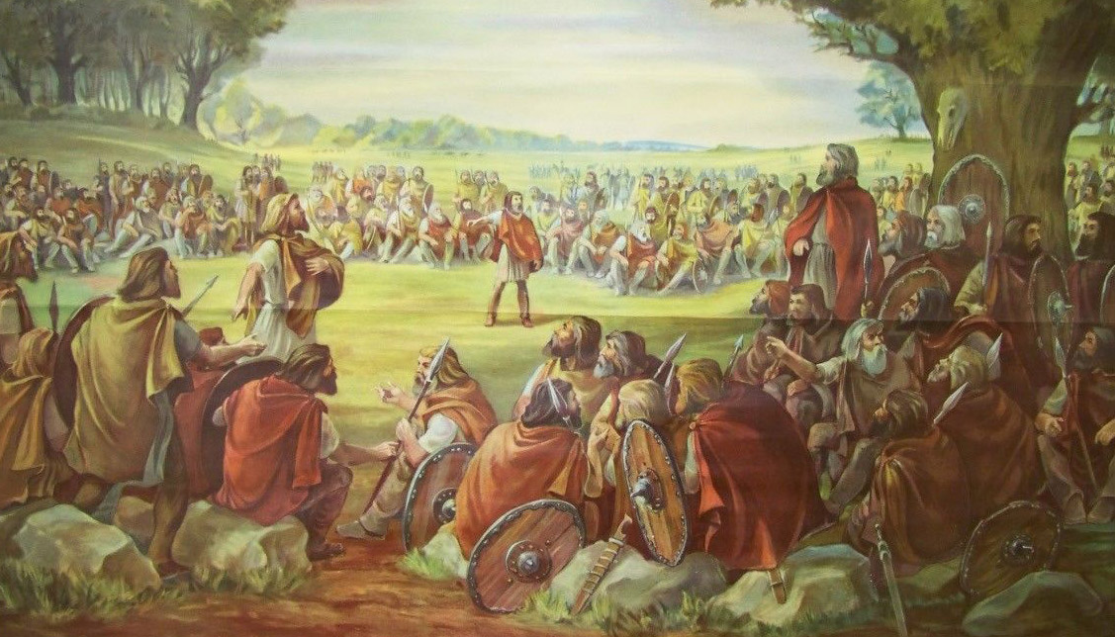

**When: Fourth Tuesday of the month, 9-10.30am** (Nov.-Dec. combined)

*January 28*

*February 25*

*March 24*

*April 28*

*May 26*

*June 23\**

*July 28*

*August 25*

*September 22*

*October 27*

*December 1*

**Where: United Way of Metropolitan Dallas**, 1800 N. Lamar St.,Dallas, Texas 75202. Coffee and water provided.

(*June 23rd’s meeting only will be at the J. Erik Jonsson Public Library, in the Community Showcase Room, 1st Floor, 1515 Young St., Dallas, Texas 75201)