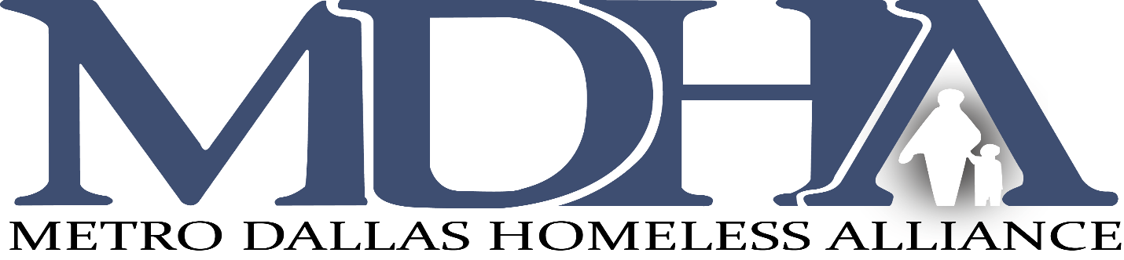

Board of Directors Meeting
2801 Swiss Avenue, Dallas Texas
Conference Room
Friday, January 17, 2020 at 9am

AGENDA

- Welcome/Introduction  Board Member Commitment & Conflict of Interest Statement | Karen Hughes
- Approval of Meeting Minutes of November 15, 2019 | Karen Hughes | Voting Item & distribution
- CoC Assembly Updates | Dustin Perkins
- Committee Reports  - Executive Committee  - Nominating Committee  - Finance Committee  - HMIS Committee | Karen Hughes  Traswell Livingston  Edd Eason  David Noguera | Voting Items & distribution:  - Family Gateway award of the CAS funds  - 2020 MDHA Budget & Auditor Selection FY2019  - HMIS MOU and User Fee schedule
- President/CEO Report | Carl Falconer

